SUPERVISION
Date / time: 30/10/2025

Main issues discussed
1. Principles for research and writing. The work must be closely linked to the research question. The experimental report should clearly explain how the results relate to the research question, and any experiment or primary research should show how it helps answer it. Always remember that everything I do should be centred on one research question or a set of research questions.
2. Process documentation and weekly report format
3. Initial materials and a “slow start”. There is no need to worry about the limited detail or slow start at the beginning. I should clearly explain the early-stage work, including how the proposal and ethics application were completed, how the research topic was chosen, and why it was meaningful or interesting to me. It is enough to state that these activities took place at the start of the project, even if there is not much detail.
4. Robust and maintainable code is a technical contribution because it supports reproducibility and allows other researchers to extend my work. Nowadays, journal and conference submissions often require code and data to be provided.

Work shown
- Present the performance of MiniRocket, MultiRocket, and TST on the LARa dataset.
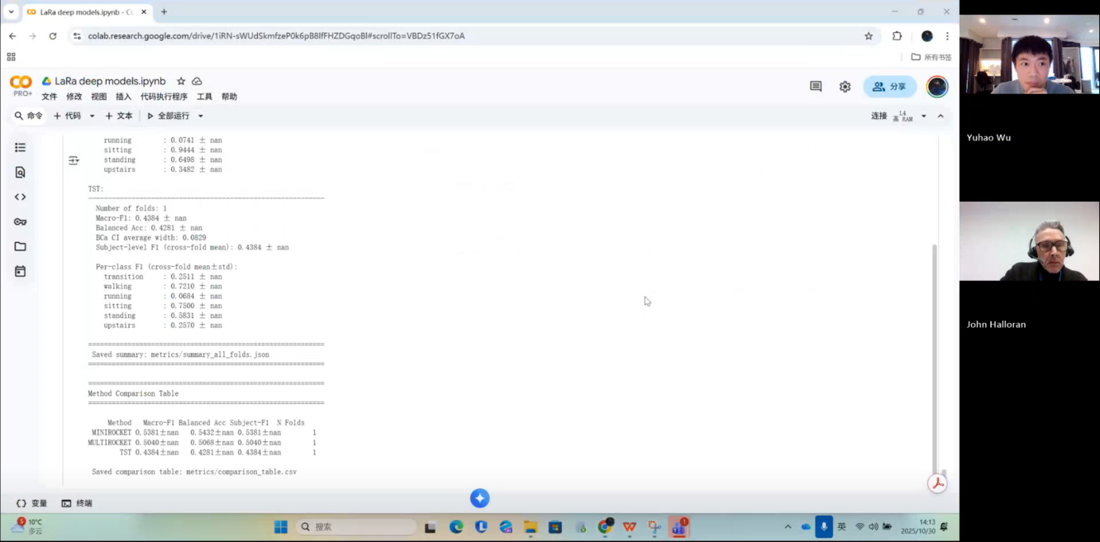

- I showed my weekly project progress template to my supervisor, Halloran.
Answer: I like you structure. No need to change anything else. Add action items at the beginning, and add next week’ s action items at the end.
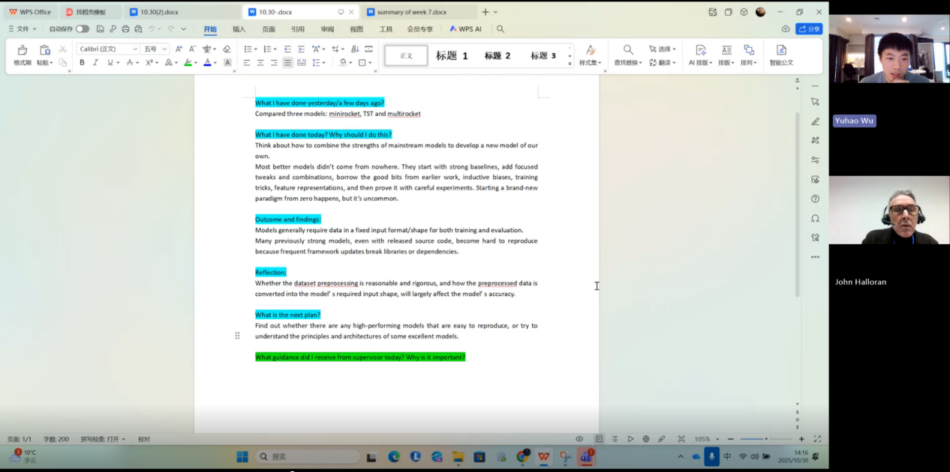

- Provide an in-depth, technically detailed explanation of how kNN, Random Forest, and InceptionTime work.
Answer: It is a good choice to explain how these models work in more detail and at a deeper level. However, it is still a bit dense and needs more explanation of their underlying principles.
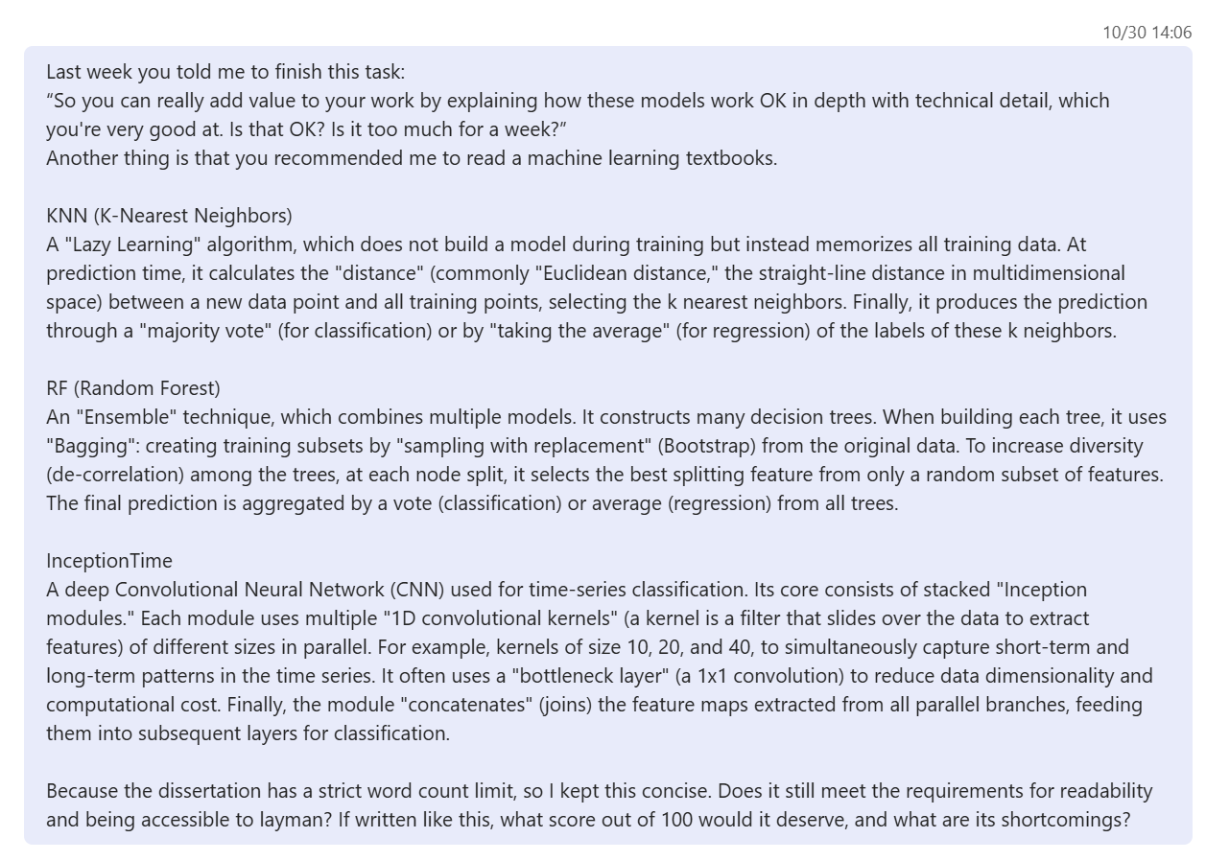

Questions asked; how questions were answered
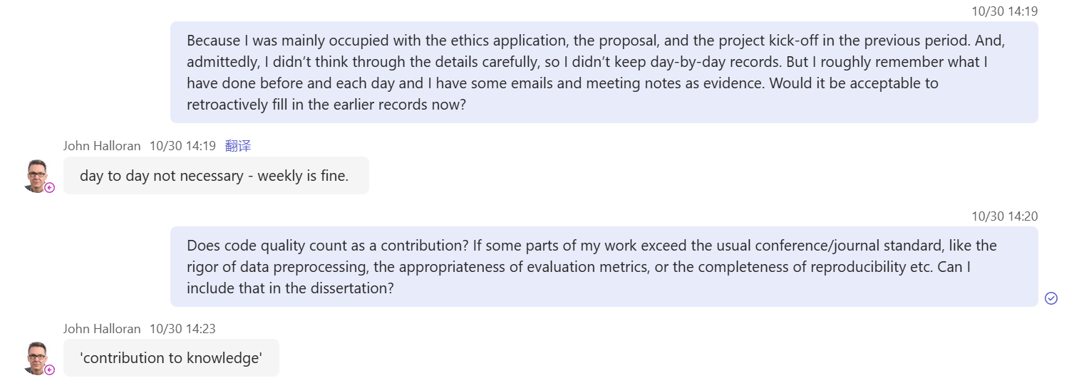
Answer
1. You don’t need to keep day-by-day records. Daily records are not required; doing it weekly is enough.
2. Yes, this is important. The technical quality of your work really matters, the technical part counts for 30% of your work.

Email
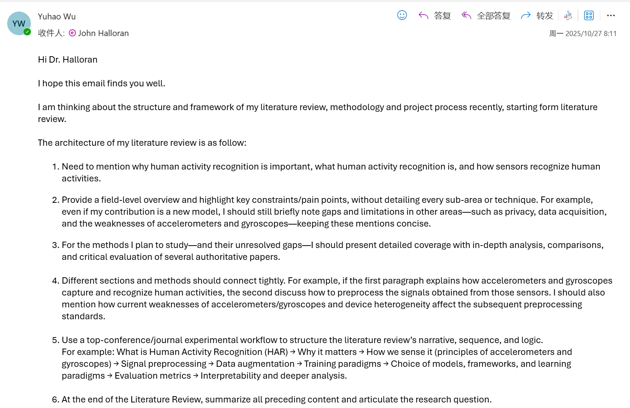
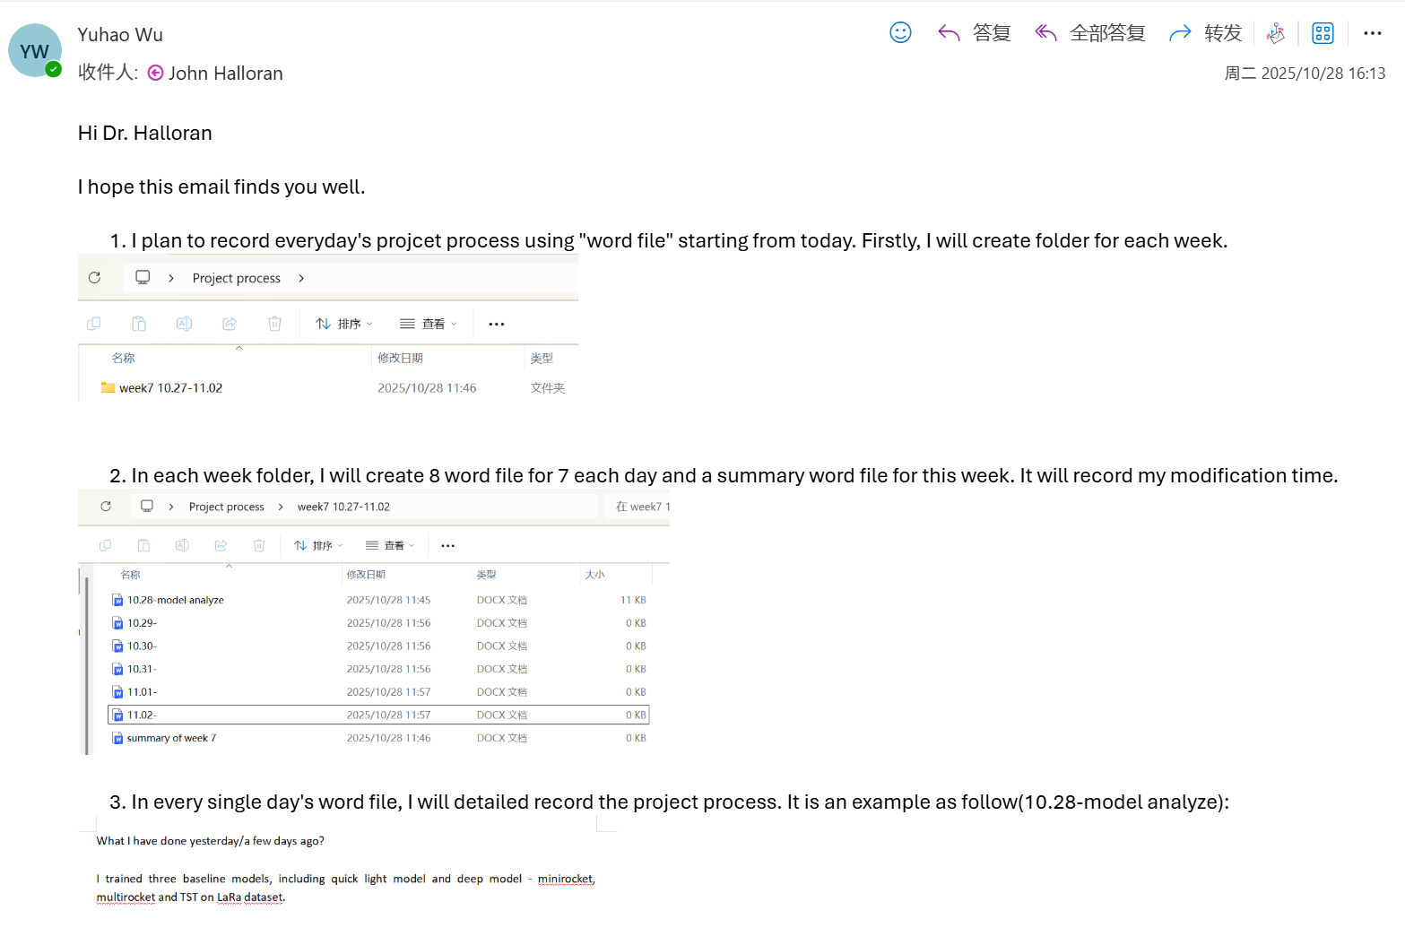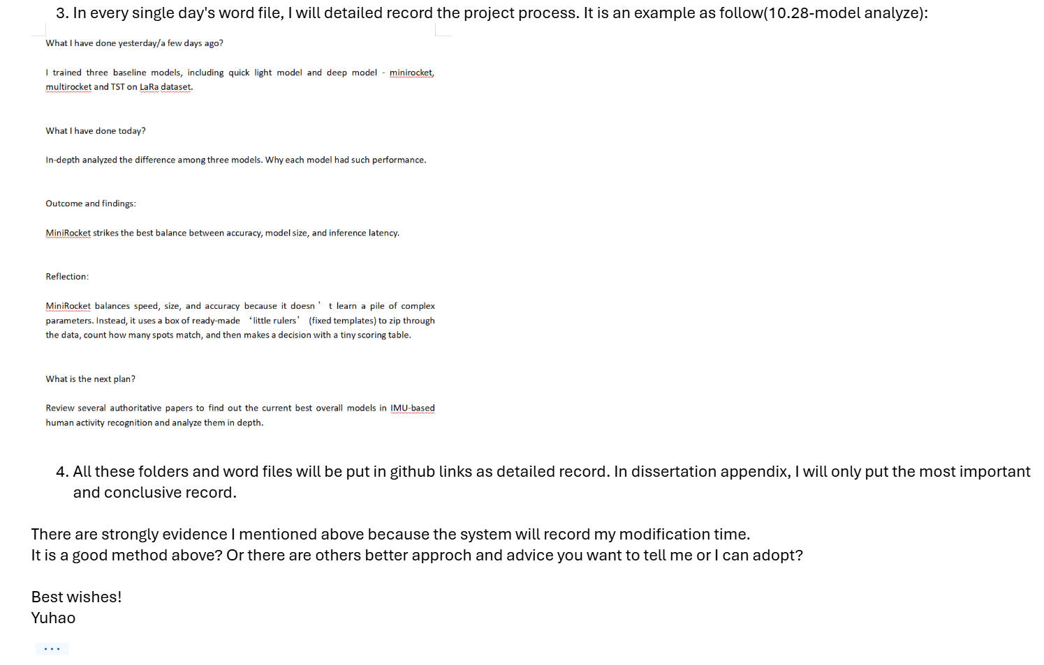

Computing Project
WORK DONE
1. Solve the problem of MultiRocket’s slow training speed on the RealWorld dataset.
2. Measure the energy consumption of the six baseline models.
3. Start designing a new model and add a state-of-the-art model as an additional baseline.
4. Read the machine learning book recommended by my supervisor.
5. Completed the sensitivity and robustness experiments for MiniRocket, and statistical analyses for Random Forest.

Issues and challenges
- Selecting which SOTA models to include in the experimental comparison is challenging because there are many SOTA models, some are not suitable for my research question, and there are also limitations in computing resources and time.
- A new model was designed, but its performance on RealWorld was only moderate and still needs improvement.

Actions for next week
1. Think about how to design a new model based on rTsfNet and show the experimental results to my supervisor next time.
2. Ask my supervisor whether solving the gradient explosion problem can be written up in the dissertation.

Link to recording
https://livecoventryac-my.sharepoint.com/:v:/g/personal/wuy176_uni_coventry_ac_uk/IQD45v4X2lX4T7BqcGRptJ1fAUwDTWgQCiL4CquUKBRClwA?nav=eyJyZWZlcnJhbEluZm8iOnsicmVmZXJyYWxBcHAiOiJTdHJlYW1XZWJBcHAiLCJyZWZlcnJhbFZpZXciOiJTaGFyZURpYWxvZy1MaW5rIiwicmVmZXJyYWxBcHBQbGF0Zm9ybSI6IldlYiIsInJlZmVycmFsTW9kZSI6InZpZXcifX0%3D&e=uXAhZP

